Final Fantasy Tactics (1997, PlayStation), Square. BATTLE MODE

1. Composition
Tangible space | In red. A « virtual chessboard » made of terrain and characters.
Intangible space | Menus can appear anywhere on the screen; some data elements are layered on tangible space.
Negative space | The backdrop behind the floating chessboard space. Dynamically adjusts according to framing.
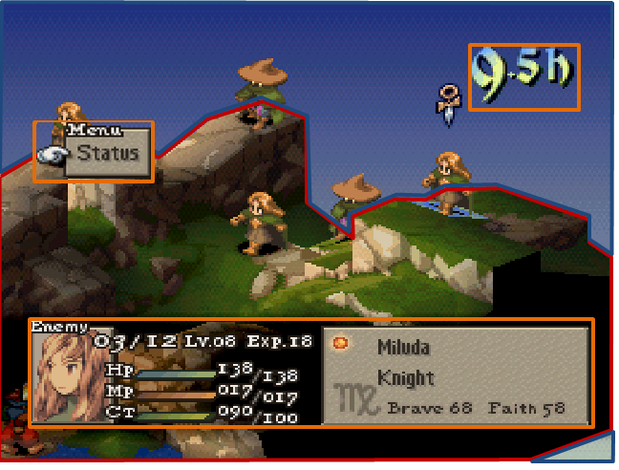

External | Zero Ergodic
2. Ocularization

3. Framing mechanisms | Anchor : Anchorless | Mobility : Unrestrained

4. Plane Analysis
 | Agents | In-game | Off-game
Graphical materials | Raster graphics (sprites) | Real-time polygons | Static backdrop (negative space)
Projection method | Axonometric | Axonometric | -
Angle of projection | 3/4 view | 3/4 view | -

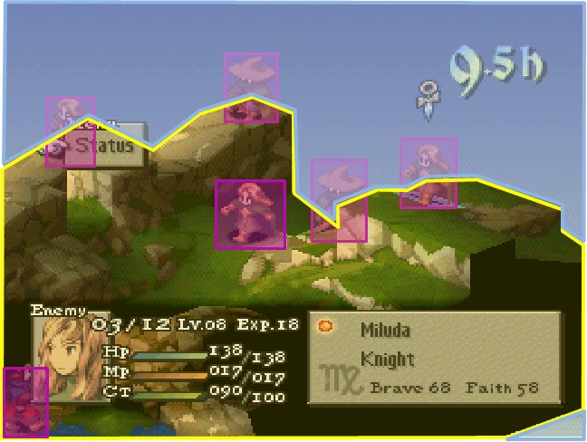

Notes :
The virtual chessboard delimitates the in-game environment and tangible space. There is no off-game environment on display that would create a sense of spatial continuity between the chessboard and the backdrop.

The framing dynamically alternates between anchorless/unrestrained (when the player plans his next move) and subjective/authoritarian (when an event happens, it is automatically framed ).

The hybrid graphical materials create a jarring and “wobbly” feel to the visuals that is somewhat alleviated by the fact that both sprites and terrain share the same projection method and angle.

